Linux Programming Lab-9
Name: Balakrishnan.P
Register number: 16MIS1159

Script 1

apt-get install sl
sl

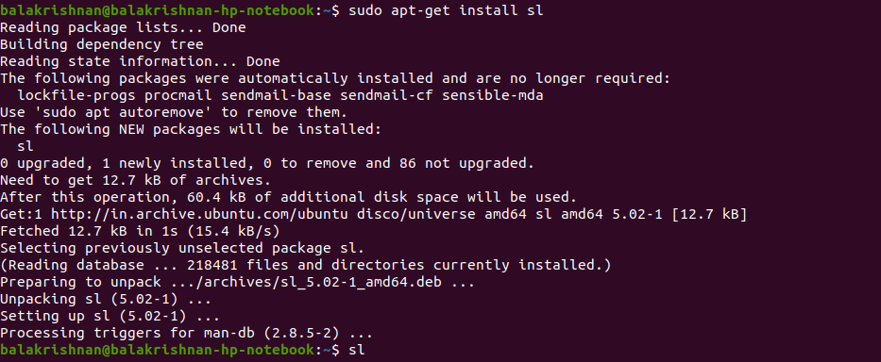
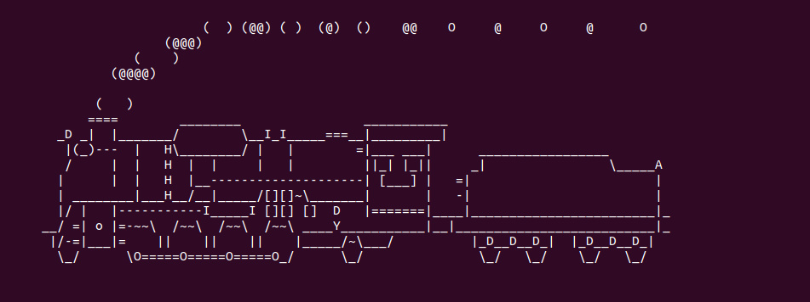
Script 2

rev

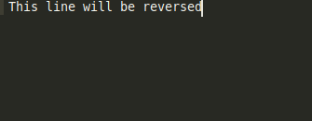

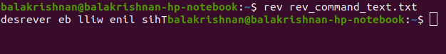

factor

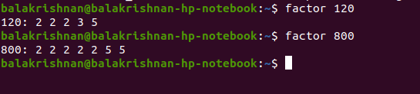

Yes

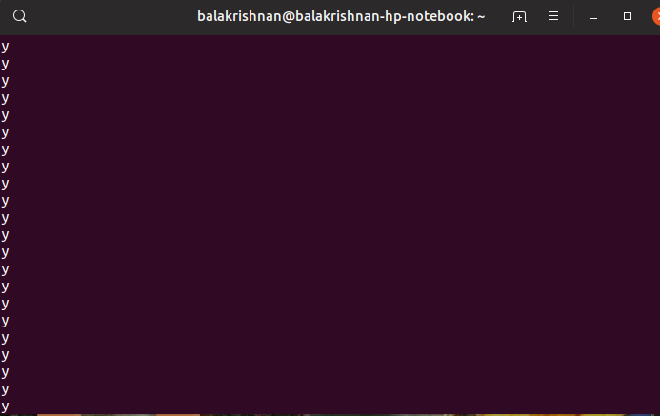

Question 2:

Write a bash shell script to monitor the health of your system. Let the details be stored and archived in any folder of your choice.

Code

#!/usr/bin/env bash

top -b -n1>top_output.txt

tar -cvf 'lab 9 online.tar' 'top_output.txt'

Crontab editor code

Note: Here the Archive folder creation will happen after every two minutes just two verify the output.

Before saving crontab editor
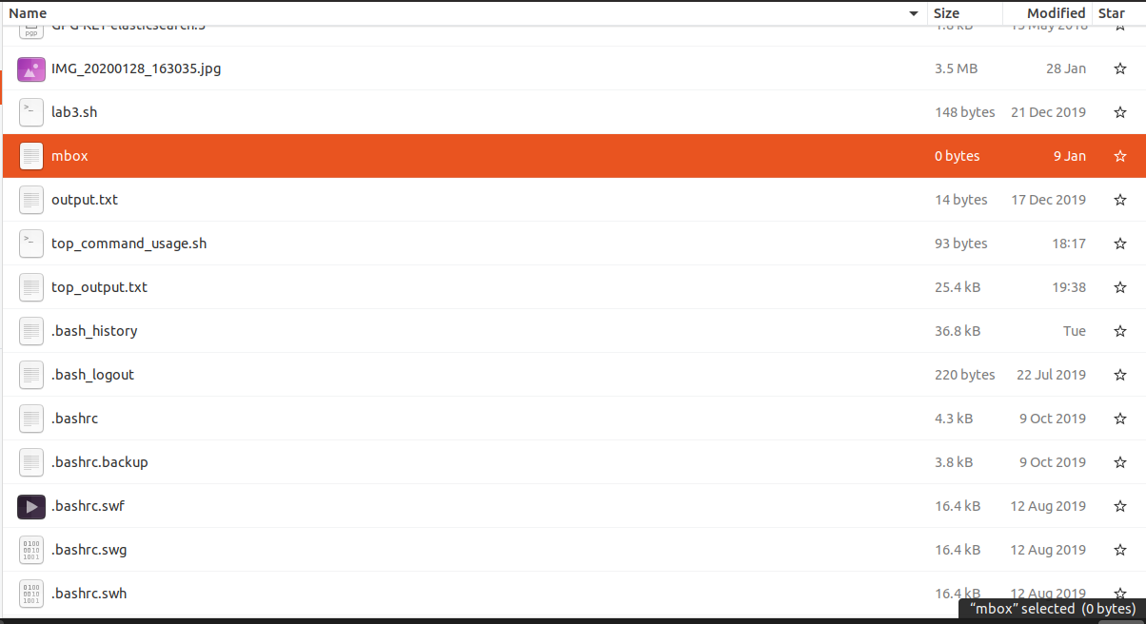

After saving the crontab editor

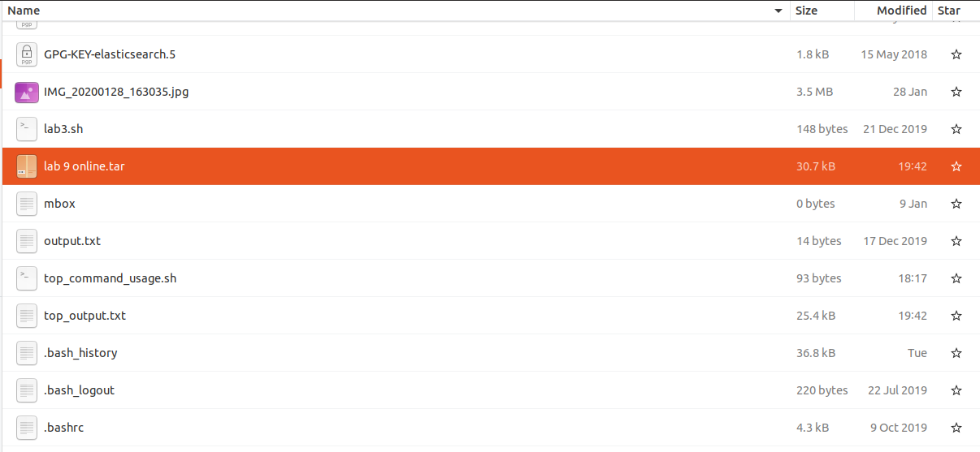
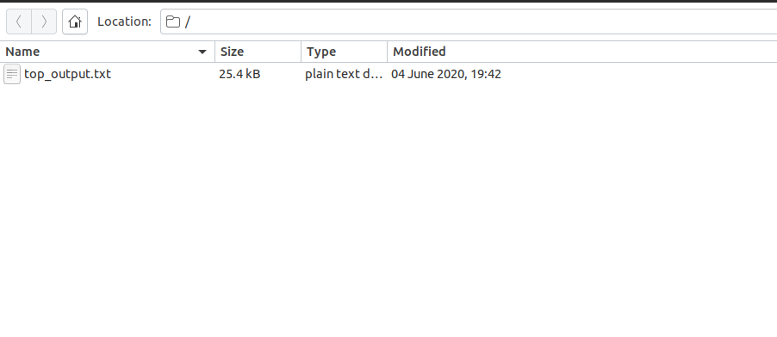
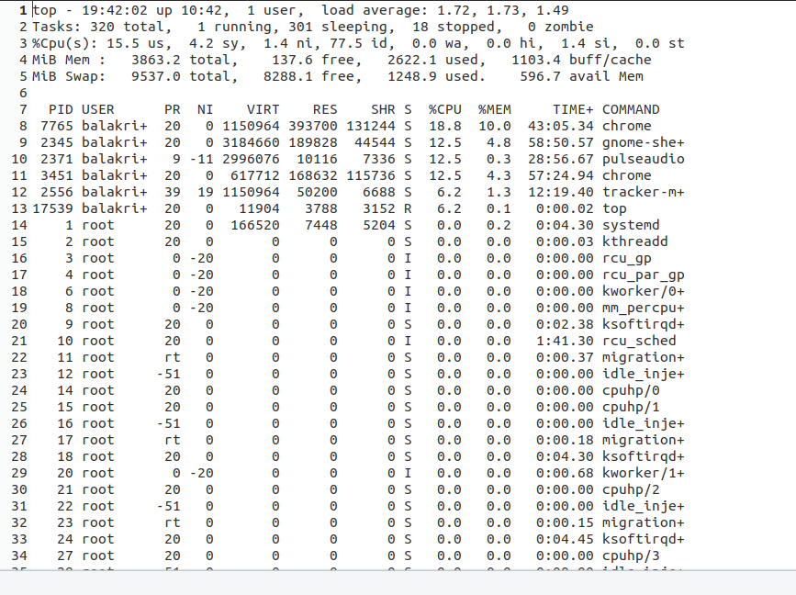
Similarly the output from the top command will save the details regarding the health of the system into the file and will be archived for every two hours if the crontab is adjusted as per the requirement.

Additional question

Write a C Program to implement Simple reader-writer algorithm using shared memory segment with semaphore

Code

server.c(this file acts as a writer and this file will writes the text “Balakrishnan” in the shared memory).

#include<stdio.h>
#include<stdlib.h>
#include<string.h>
#include<sys/types.h>
#include<sys/ipc.h>
#include<sys/shm.h>

#define SHSIZE 100

int main(int argc,char *argv[])
{
int shmid;
key_t key;
char *shm;
char *s;
//Let key=some ram=ndom integer
key=9876;

shmid=shmget(key,SHSIZE,IPC_CREAT | 0666);

if(shmid<0)
{
perror("Shmget");
exit(1);
}

shm=shmat(shmid,NULL,0);

if(shm==(char *)-1)
{
perror("shmat");
exit(1);
}

memcpy(shm,"Balakrishnan",12);

s=shm;
s+=12;

*s=0;

while(*shm!='*')
{
sleep(1);
}

}

Client.c(this file acts as a reader and will read the text and prints the text in terminal)

#include<stdio.h>
#include<stdlib.h>
#include<string.h>
#include<sys/types.h>
#include<sys/ipc.h>
#include<sys/shm.h>

#define SHSIZE 100

int main(int argc,char *argv[])
{
int shmid;
key_t key;
char *shm;
char *s;
//Let key=some ram=ndom integer
key=9876;

shmid=shmget(key,SHSIZE,0666);

if(shmid<0)
{
perror("Shmget");
exit(1);
}

shm=shmat(shmid,NULL,0);

if(shm==(char *)-1)
{
perror("shmat");
exit(1);
}

for(s=shm;*s!=0;s++)
{
printf("%c",*s);
}
printf("\n");
*shm='*';

}

Note: Both the server.c and client.c must be executed at same time using two different terminals.

